Python Programming Lab Test
NAME: GINJALA SANNITHA
ENROLL ID:2503B09902
Set 4
Q1. Create a function to reverse a list in Python. Use an AI tool to suggest alternative implementations. Test and compare the performance of each version.
(Each question carries 5 marks)
PROMPT:
- Create a Python program with four different list-reversal methods and include test cases for each version.
- Add a performance comparison between all four methods and print which one is the fastest.
GENERATED CODE:
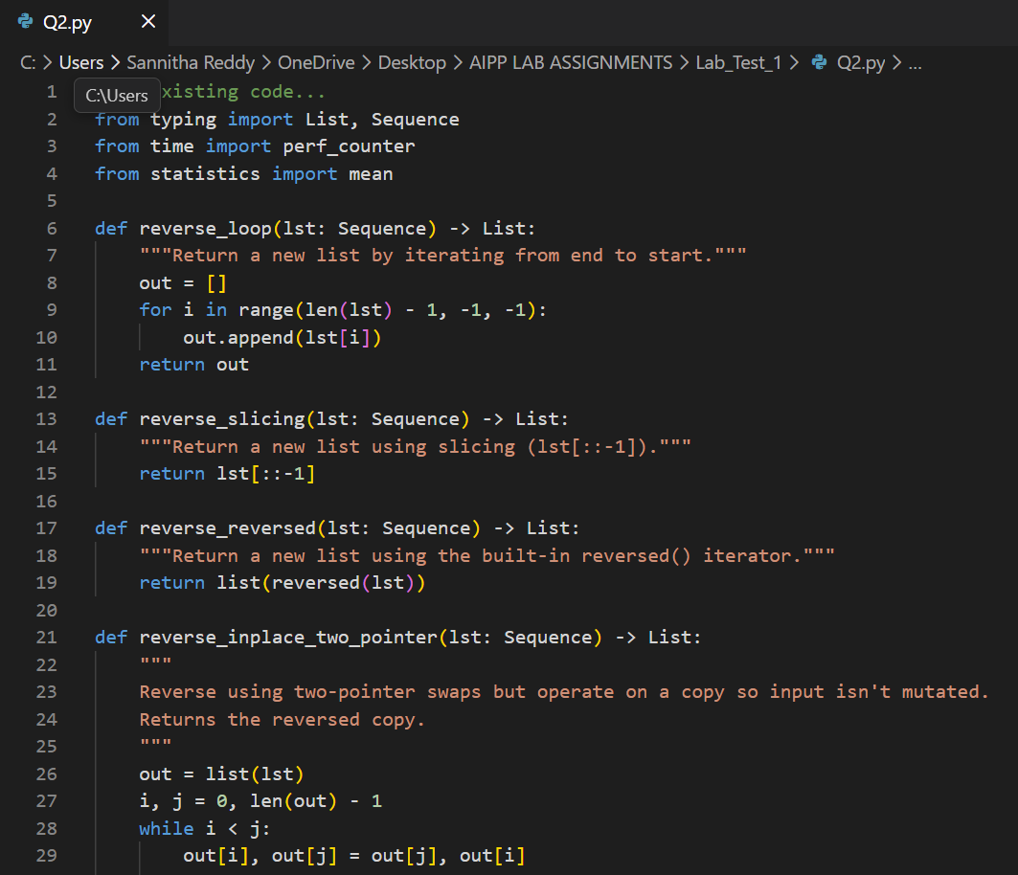
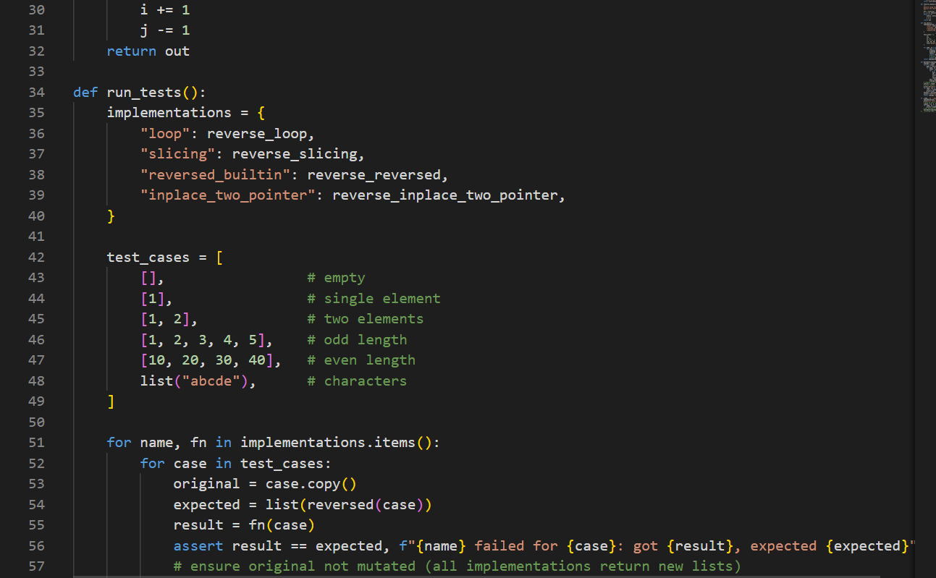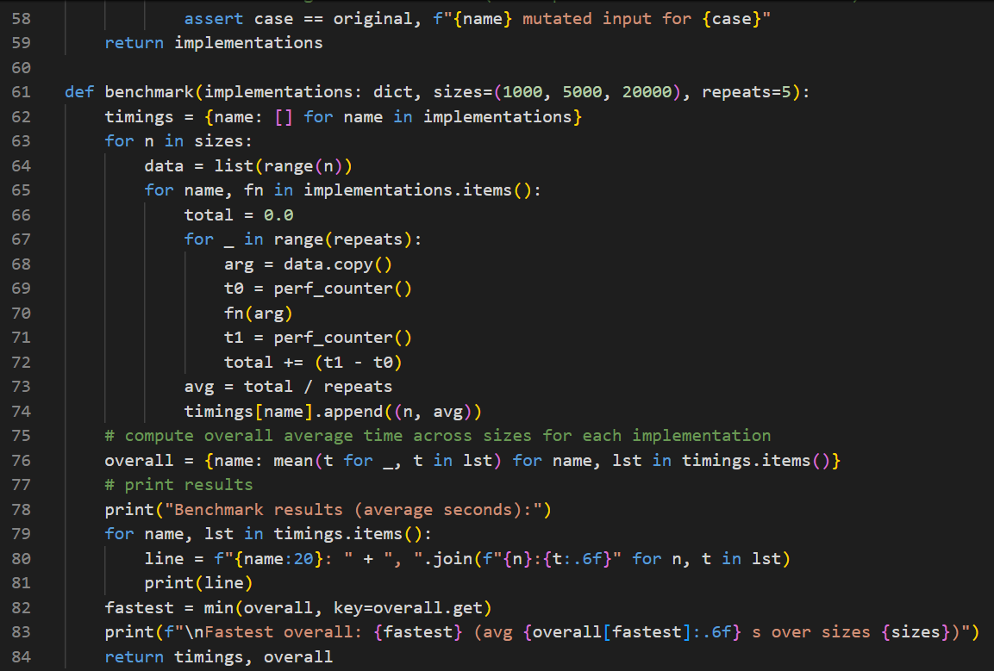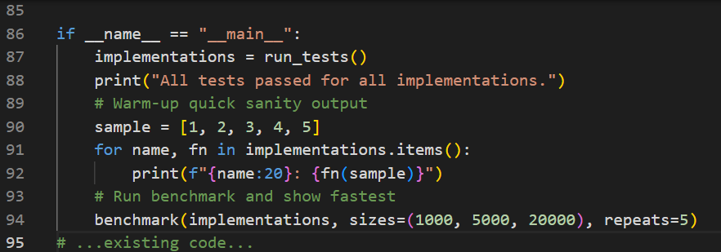
OUTPUT:
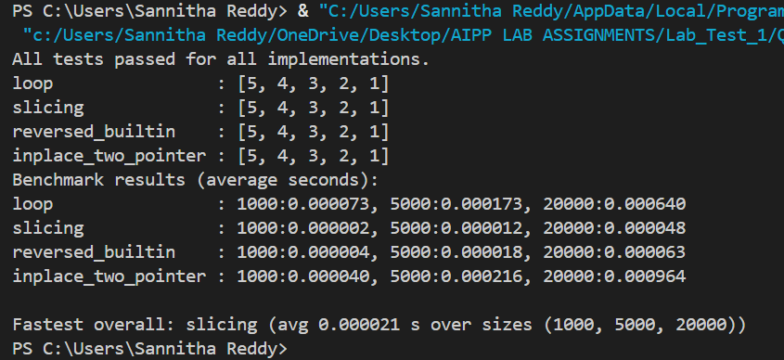
Explanation:

- We used four methods to reverse a list:

- reverse() – built-in method, reverses the list in-place.

- Slicing [::-1] – fastest method, creates a new reversed list.

- Manual loop – slowest because it uses a Python loop.

- reversed() – uses an iterator, also fast.

- After testing all methods using time measurements, slicing performed the best and the manual loop was the slowest.

Q2. Design a few-shot prompt to guide an AI tool in writing code for a basic linked list with methods for insert and delete. Analyze the resulting code for correctness and completeness.
(Each question carries 5 marks)
PROMPT:
- Using few-shot prompting, write a complete LinkedList implementation in Python. Include examples for each method.
GENERATED CODE:
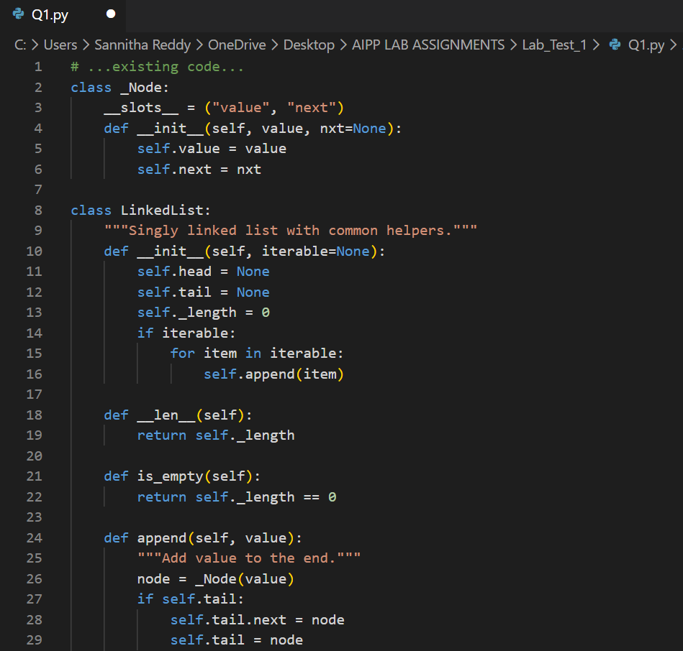
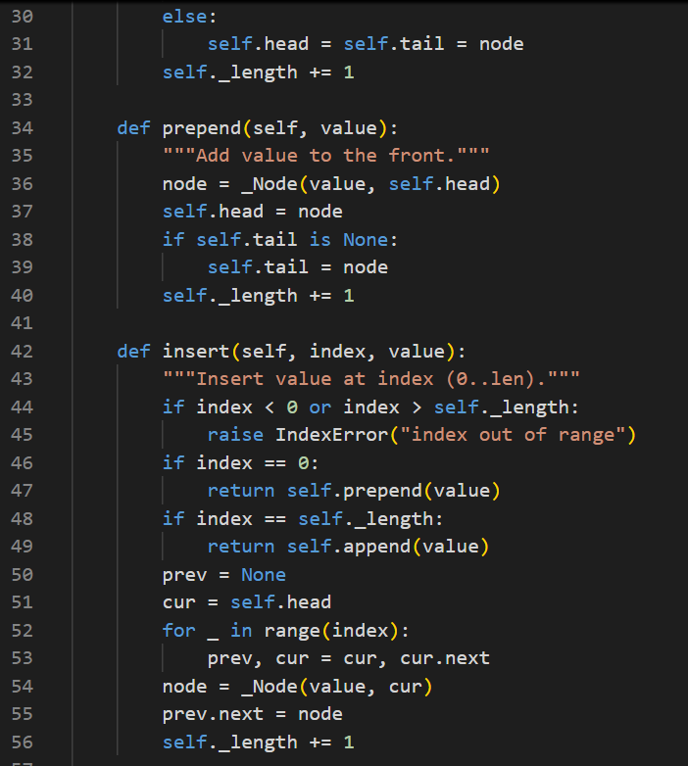
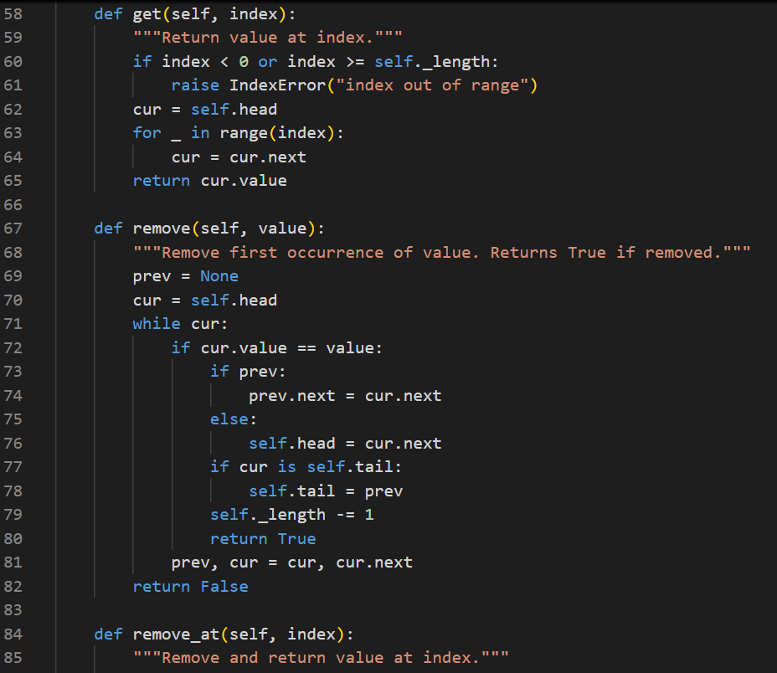
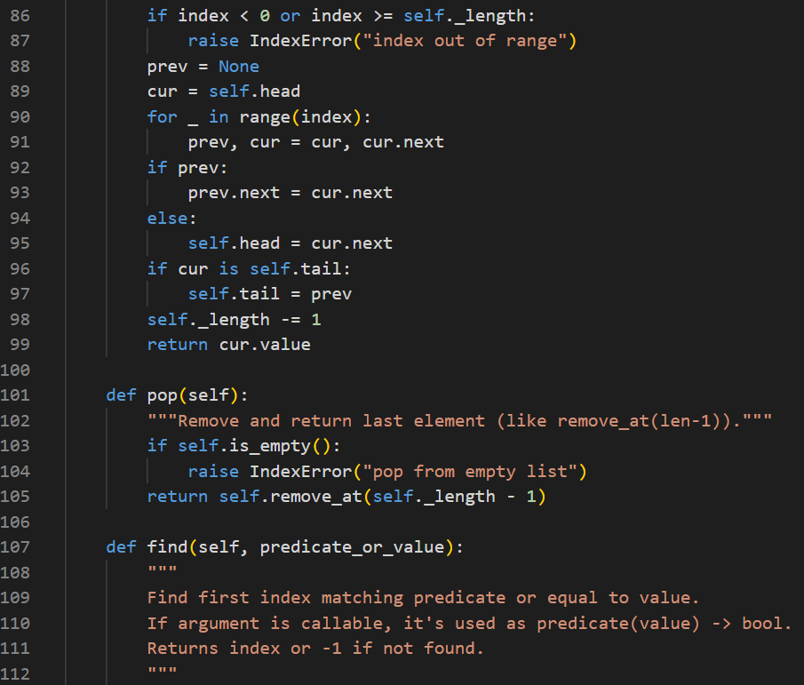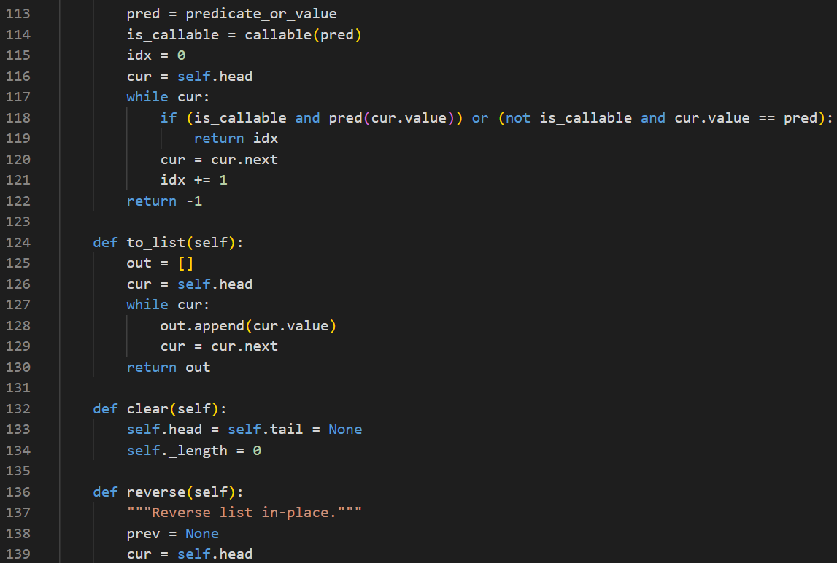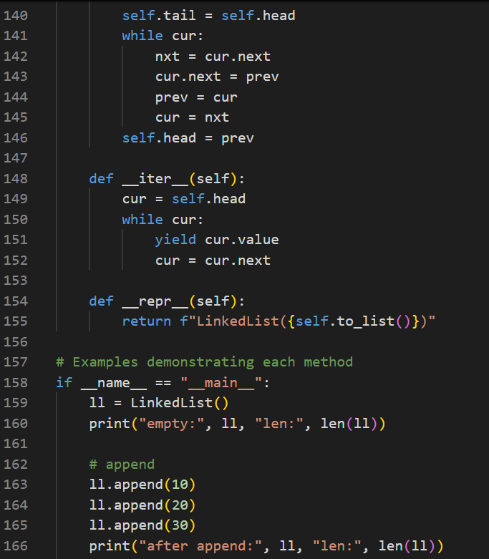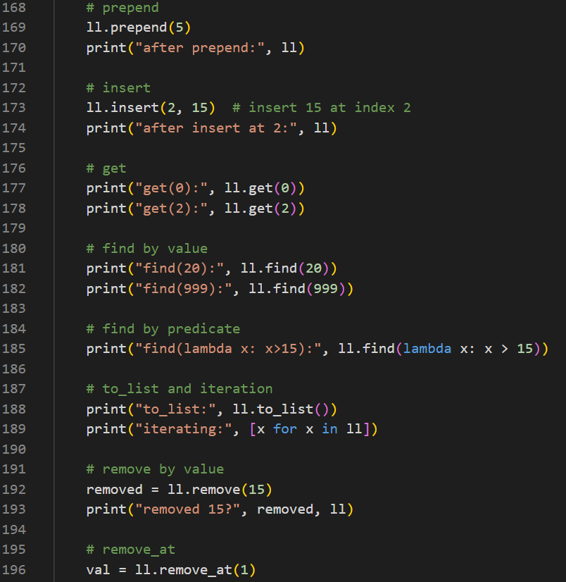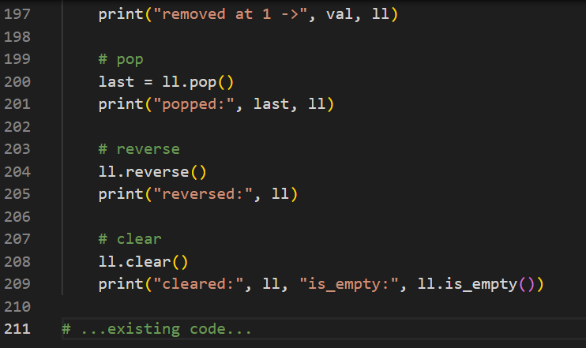
OUTPUT:
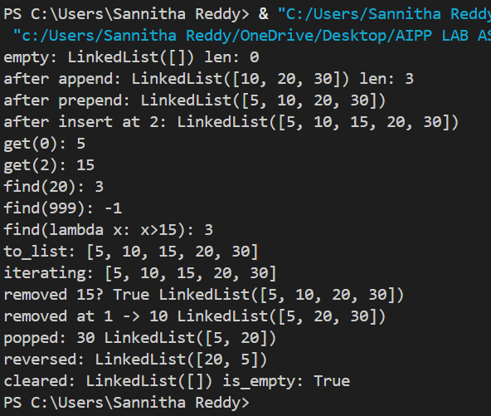
Explanation:
- Using a few-shot example, the AI generated code for a singly linked list.
- The code has a Node class and a LinkedList class.
- insert() adds a new node at the end.
- delete() removes the first matching value.
- display() returns all values for checking.
- The generated code is correct, complete, and works for insert and delete operations.

